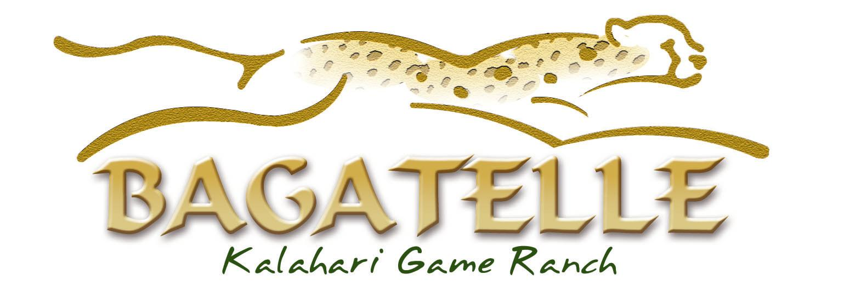
Bagatelle Signature Treatments
escape...relax...refresh...enhance...

Kalahari Calabash Sole Survival 30 min N$250
Sink into deep relaxation with a signature foot and lower leg ritual that sooths away tired, aching feet and legs with an authentic, sun baked Kalahari Calabash and indulgent aromatic fragrances.

Kalahari Tsamma Hand Ritual 30 min N$250
Refresh and unwind with the delicate aroma of Tsamma (the indigenous Kalahari watermelons) and the infused fragrance of fresh, wild grasses. Surrender your mind and welcome the feeling of richly nourished and moisturised arms, hands and nails.
Ideal for dry, thirsty skin.

Kalahari Khoi-Khoi Escape 30 min N$400
Escape with a deeply relaxing back and neck massage. Enhance your experience with the Kalahari Message Stones as they deliver a decadent, deep pressure massage to leave you feeling renewed and uplifted.
*Customise your treatment with an Aromatic Massage Candle

Kalahari Desert Glow Exfoliation 45 min N$350
Feel refreshed with a unique full body exfoliation. Unveil lustrously smooth skin with a personalised blend of your desired Kalahari exfoliation medium and hydrating blends of nourishing botanical oils. The perfect pre treatment for flawless self tan applications or a truly original desert glow
Personalize your treatment with a choice of these three exfoliation mediums:
Red Dune Sand (pure, fine red Kalahari Dune Sand)
Desert Mineral Crystals (from the crystallised Salt Pans of the Kalahari)
Aromatic Botanical Blend (Sun dried fibers from the succulent leaves of the Aloe Plant)

Kalahari Rolling Sands Massage 60 min N$550
Relax and escape with a full body message. Experience the sensation of rolling dunes of the Kalahari with a deep massage utilising signature dancing arm movements.
*Customise your treatment with an Aromatic Massage Candle.

